Supplemental Materials and Methods
Histopathological Analysis of Rat Prostate Cancer
After imaging, prostate tissues were excised, formalin-fixed and paraffin-embedded. Tissue sections (10 μm) were stained with Hematoxylin and Eosin (H&E) following standard protocol. Before H&E staining, samples were fixed with freshly prepared 10% PBS buffered formalin for 24 h. After deparaffinization, 3 μm of prostate tissue section was cut for H&E staining. Cancer was defined as extensive proliferation into a solid mass with little or no normal gland. The α_{v}β₃ integrin expression was determined by immunohistochemical staining via the standard procedure. After deparaffinization with xylene and alcohol, prostate tissues were incubated in 10 mM citrate buffer (pH 7.4) for 10 minutes at 90 °C for antigen retrieval. The 0.3% H₂O₂ in methanol was added to the samples at 4 °C for 30 minutes to inactivate the endogenous peroxidases. After incubation with 0.5% Triton for 10 minutes, the sections are treated with 10% normal goat serum for 1 h at room temperature for antigen blocking. Polyclonal antibody (Abcam, England) was then added to the sections for 1 h at 37 °C. Finally, after being washed with PBS, all sections were incubated with horseradish conjugated biotinylated secondary anti-mouse antibody (Vector Laboratories, America) for 1 h. The immuno-reactivity on the tissue sections was visualized using the peroxidase substrate DAB. The nuclei were counterstained by hematoxylin.
CEUS imaging of Prostate Cancer
Three days after the operation of orthotopic PCa, CEUS was performed to image local PCa processing. Rats were first appropriately anesthetized. CEUS imaging was performed on a clinical US imaging system (Logiq E9 digital premium ultrasound system, GE, USA). Images were collected using a broadband ML6-15D high-frequency probe.

Supplemental figures and tables
Figure S1

Figure S2

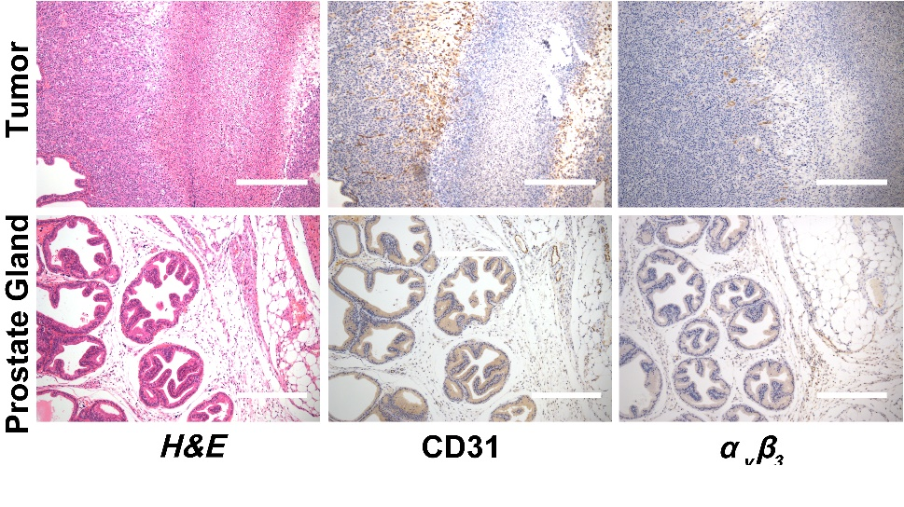

Figure S3

